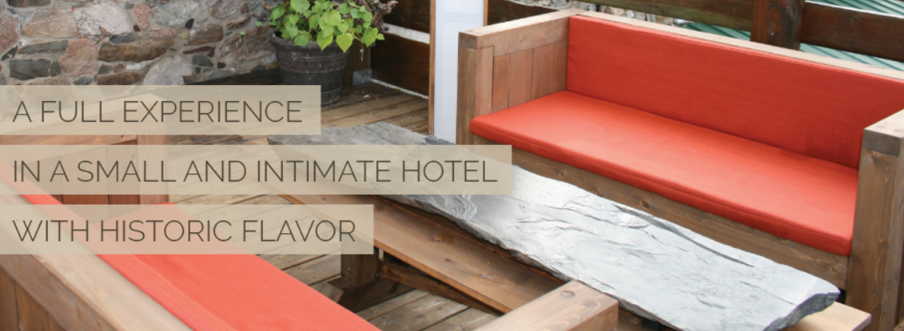

**SEPTEMBER 16, 2022**

Vanier College

Continuing Education

Software Development AEC

System Development 420-940-VA

HOTEL MANAGEMENT SOFTWARE DEVELOPMENT

RED TEAM

TEAM MEMBERS

Certify That We All Have Contributed For This Deliverable.

Deliverable 1:

PATRICK LAROCQUE, STUDENT ID: 0879202 ____________________ Team Leader

MURAT OSMONOV, STUDENT ID: 219501 ____________________

GERASIMOS VLASSOPOULOS, STUDENT ID: 2295049 ____________________

CHI-TAO LI, STUDENT ID: 9730157 ____________________

LI YU, STUDENT ID: 2295012 ____________________

CLIENT INFORMATIONS

## Ramezay Manor

492, rue Claude de Ramezay (Route 227)  
Marieville (Québec) J3M 1J6

Telephone: (450) 460-3251

P.S. This is completely new Project, without any previous content ideas.

**_________________________________________________________________________________________________**

Hotel Management Software Development Red Team © 2022 All Rights Reserve Page 1 of?

**Table of Contents**

Executive Overview.......................................................................................................................................................03

Client Description .......................................................................................................................................................03

Executive Overview.......................................................................................................................................................00

Executive Overview.......................................................................................................................................................00

Executive Overview.......................................................................................................................................................00

Executive Overview.......................................................................................................................................................00

Executive Overview.......................................................................................................................................................00

Executive Overview.......................................................................................................................................................00

Executive Overview.......................................................................................................................................................00

Executive Overview.......................................................................................................................................................00

Executive Overview.......................................................................................................................................................00

Executive Overview.......................................................................................................................................................00

Executive Overview.......................................................................................................................................................00

Executive Overview.......................................................................................................................................................00

Executive Overview.......................................................................................................................................................00

Executive Overview.......................................................................................................................................................00

Executive Overview.......................................................................................................................................................00

Executive Overview.......................................................................................................................................................00

Executive Overview.......................................................................................................................................................00

**_________________________________________________________________________________________________**

Hotel Management Software Development Red Team © 2022 All Rights Reserve Page 2 of?

**Executive Overview**

The first deliverable consists of Red Team’s project plan by reviewing the individual tasks that need to be completed, the members who will be assigned with accomplishing these tasks, and the dates that these tasks must be completed by. We created the foundation of our project by completing the front matter, Gantt chart and all other requirements.

Our client is the Manoir Ramezay HOTEL-RESTAURANT-SPA. Our goal is to improve the management system they currently have by planning the exact steps that need to be taken, in order to develop and submit an organised and functioning software management system that will give them the capability to have all bookings and client information in one database.

/*Our team put together a schedule, to give us a visual idea of ​​what we need to do and how quickly we need to do those things, to complete this project in the best and most efficient way for our client. The participants were given the tasks, most suitable for them in order to better achieve this goal. We have set specific meeting times (----- ------ ------) for group discussions, and we have lab classes for discussions. With the creation of online repositories using GitHub and Microsoft Teams, as well as many forms of team communication (personal email and phone number), our team can fully communicate and work together at any time. */Patrick

Client Description

Manoir Ramezay is a small and cozy hotel located in Marieville. The Hotel has a total of fourteen rooms, nine of which are standard rooms and five suites, all meticulously decorated to respect and preserve the history that is still alive within its walls. Furthermore, guests can also take advantage of the 4-season spa and living room area located on the roof terrace.

The owners of the hotel are a couple who purchased the establishment four years ago. Since it is a smaller scale Hotel, they only have three employees. Staff includes a front desk clerk, a maintenance assistant and a cleaning associate. The owners oversee the restaurant, which provides breakfast, and they also supervise the overall operations of the business.

Both owners have basic knowledge of Microsoft Office. To improve their business, they would like to enhance their software management system and use it to run their Hotel in a more organized and efficient manner.

During our discussion with the owners, they informed us that the major problem they currently have is how to connect all bookings from various websites and room availabilities in real time to their management system. Moreover, another issue they face is that their system does not allow them to save past customers information. Our plan is to develop a software management system that can fulfill both requirements simultaneously.

**_________________________________________________________________________________________________**

Hotel Management Software Development Red Team © 2022 All Rights Reserve Page 3 of?